SW Engineering CSC648/848 Fall 2023

Section 02

Team 02

Milestone 2

California SafetyNet

Lukas – lheber@sfsu.edu – Team Lead, Github Master
Marshall – back end lead
Danial – front end lead
Ely, Mark, Sanjith

Date: 10/21/2023

Date submitted: 10/3/2023
Date revised: 10/21/2023

Content
1. Functional requirements - prioritized 3
2. UI Mockups and Storyboards 5
3. High level Architecture, Database Organization 9
4. High Level UML Diagrams 13
5. Risks 16
6. Project management 17

1. Functional requirements - prioritized
- Adherence to Regulations: Software shall have a resource link page to county regulations for data security and privacy.
- Administration Control Panel: Administrators shall be able to access an interface where they may control users, content, and notifications.
- Alert Initiation: Administrators shall be able to set off notifications depending on predetermined parameters, such as COVID-19 infection rates, wildfire evacuation levels, and security issues.
- Community Forum: Shall give people a place to contribute information and take part in community conversations.
- Crowdsourced Data Submission: Users shall be able to input crowdsourced data, such as information about roadblocks, detours, and security issues.
- Customizable Alerts: Users shall be able to change alert choices, including the alert categories and transmission methods.
- Data Integration in Real Time: Shall be able to obtain current information on COVID-19, weather patterns, and wildfires by integrating with governmental organizations.
- Embedded messaging: Users shall be able to communicate during emergencies by sending and receiving messages within the platform via in-site messaging.
- Emergency Resource Directory: Shall offer a thorough listing of all available emergency services, including hospitals, fire stations, police stations, and shelters for evacuees.
- Entry for County Metrics: COVID-19, weather, wildfire, and security metrics shall be entered and updated by county departments (Health, Security, Weather, and Fire).
- Feedback Mechanism: Shall implement a feedback system so that users may report problems and make suggestions for changes.
- Help Center: Shall offer a thorough help center with FAQs and instruction manuals.
- Mapping Interface: Shall interact with interactive maps to view emergency occurrences, metrics, and county-specific data.
- Marketing Integration: Shall develop marketing plans and collaborate with regional government organizations to increase the uptake of the platform.
- Multilingual Support: Shall support several languages to serve California's multicultural population.
- Multi-Platform Support: Shall improve usability and accessibility by expanding the service to mobile apps and making sure consumers can access it on a variety of hardware and software.
- Privacy Settings: Users shall be able to control their privacy preferences and decide what information they want to make available with others.
- User Login: Users shall be able to register.
- User Access: Users shall be able to access the system by logging in.
- User Registration: Users shall be able to register for accounts only by providing a working email address as confirmation in order to access the platform's features.
In the following table each requirement is referenced by its unique number and assigned a priority from P1 (must be implemented) to P3 (opportunistic):
Requirement | Priority
1 | P1
3 | P1
6 | P1
10 | P1
11 | P1
12 | P1
13 | P1
2 | P2
7 | P2
15 | P2
16 | P2
17 | P2
4 | P3
5 | P3
8 | P3
9 | P3
14 | P3
18 | P3
19 | P3
20 | P3

2. UI Mockups and Storyboards

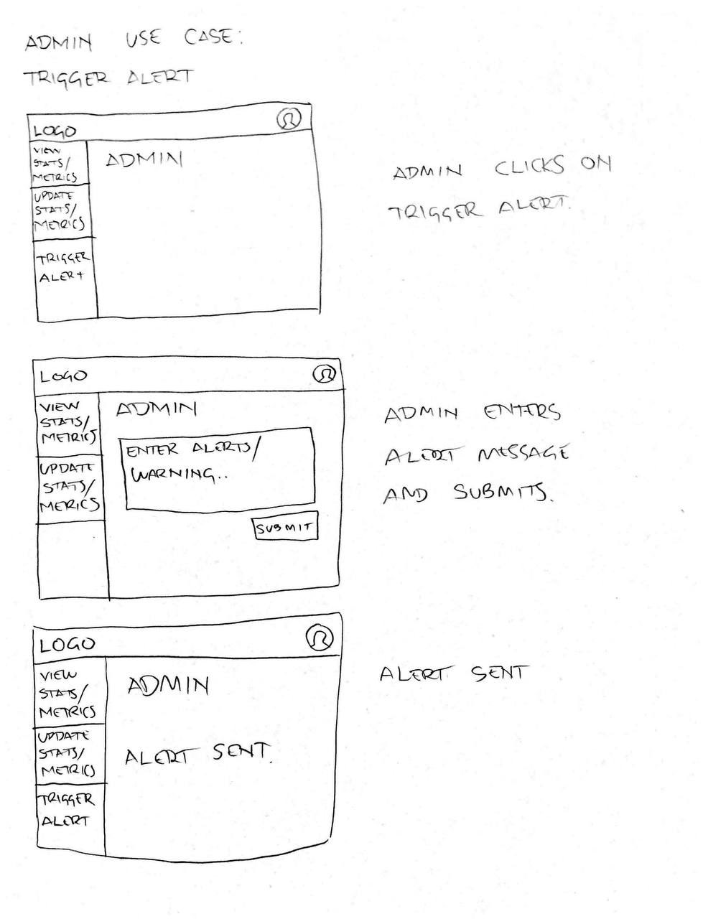

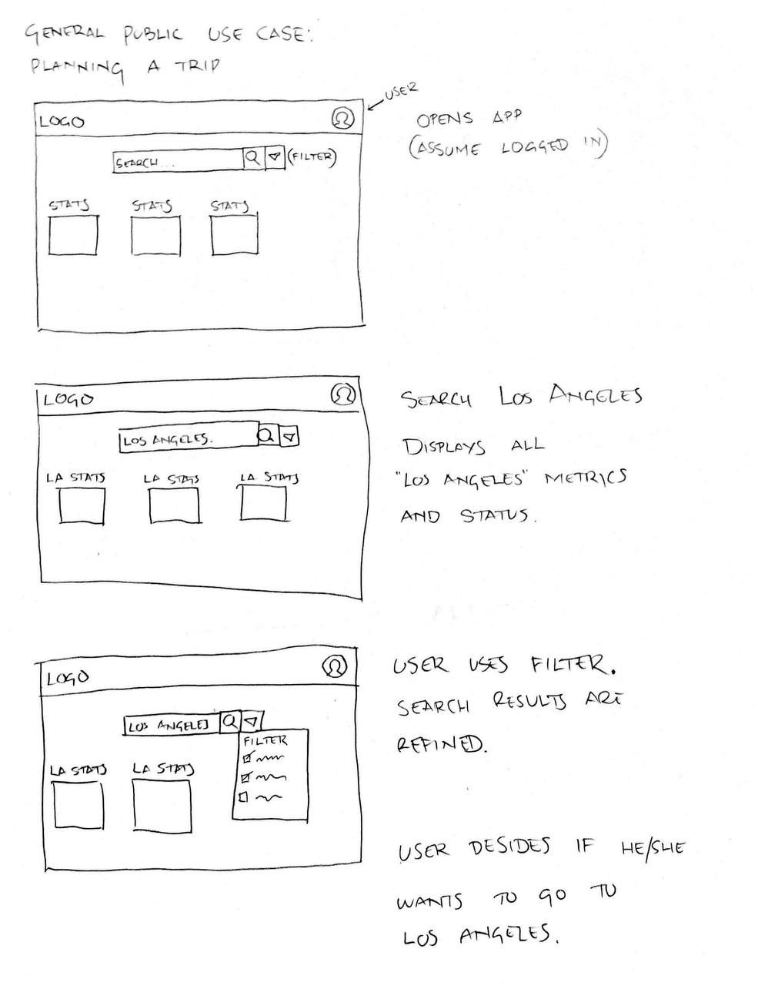

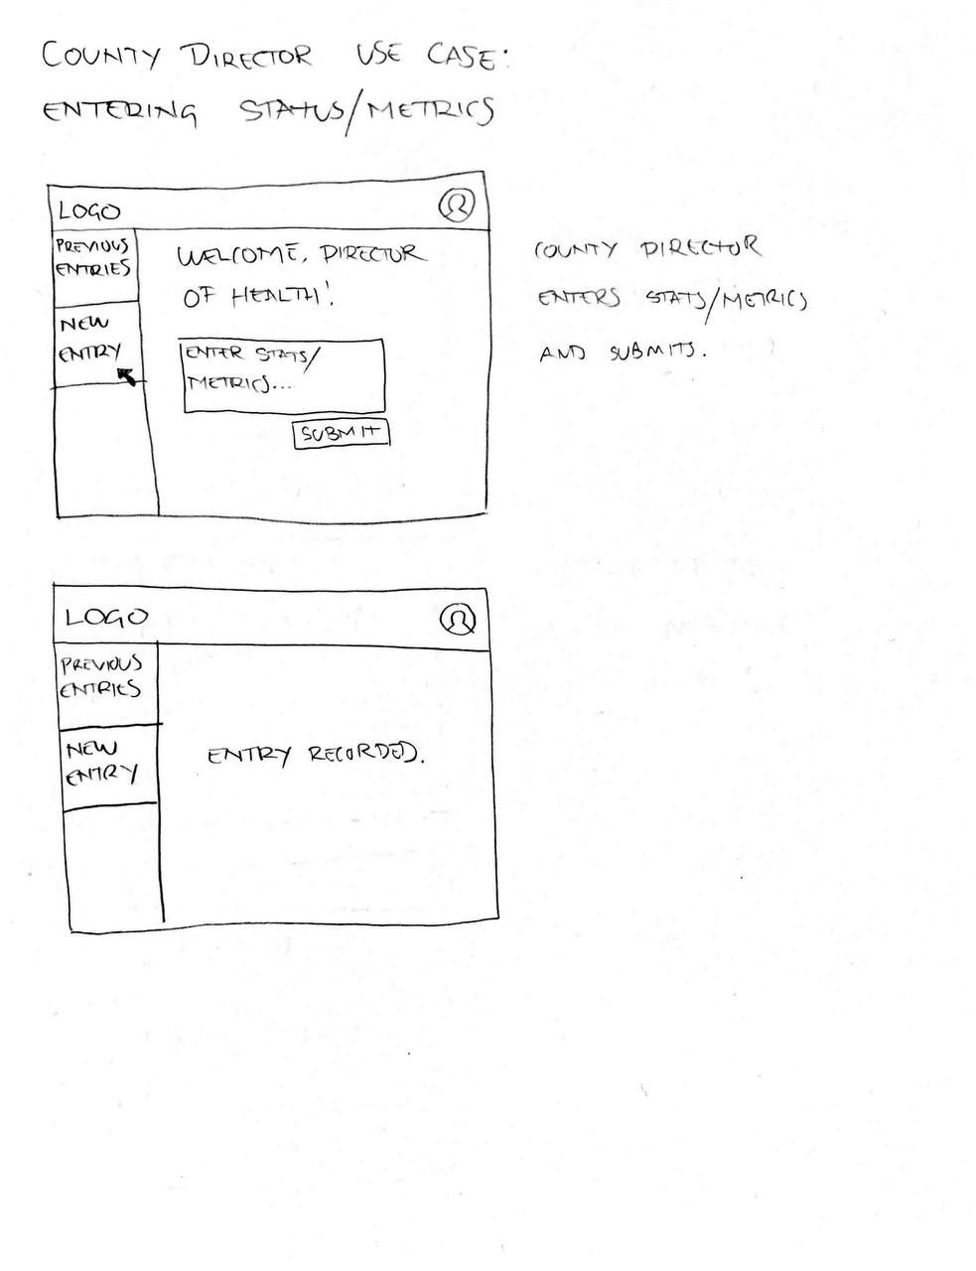

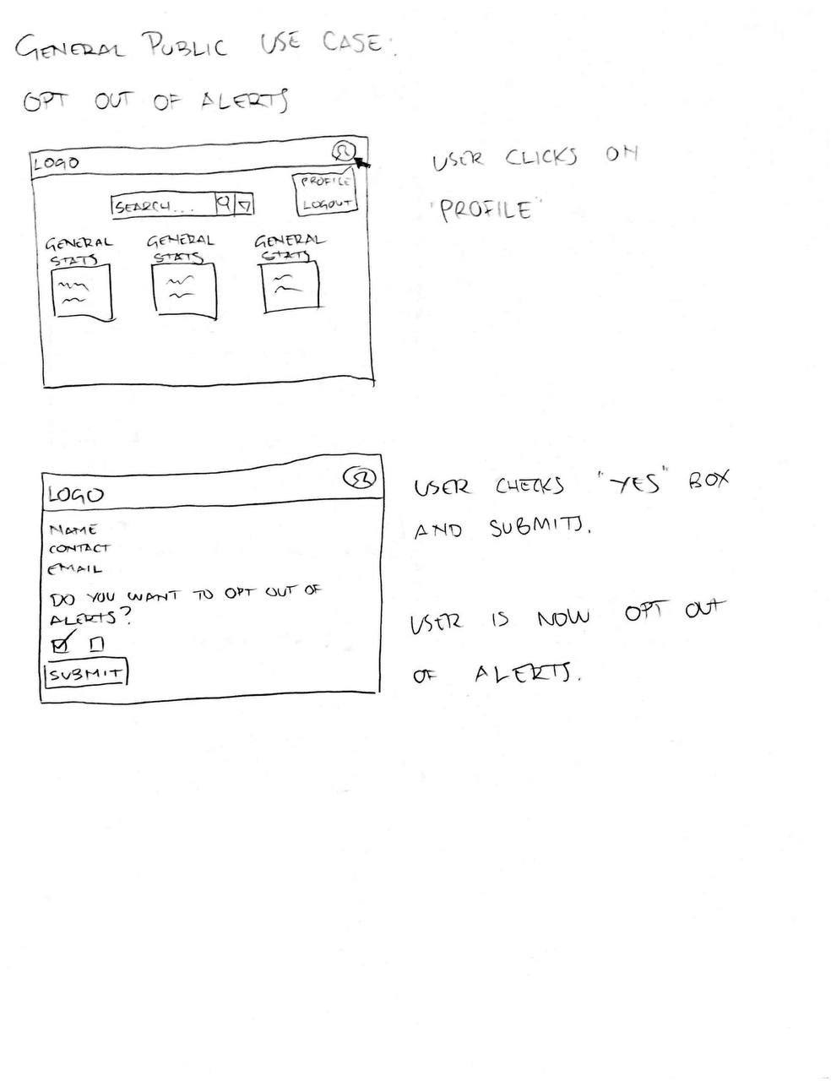

3. High level Architecture, Database Organization
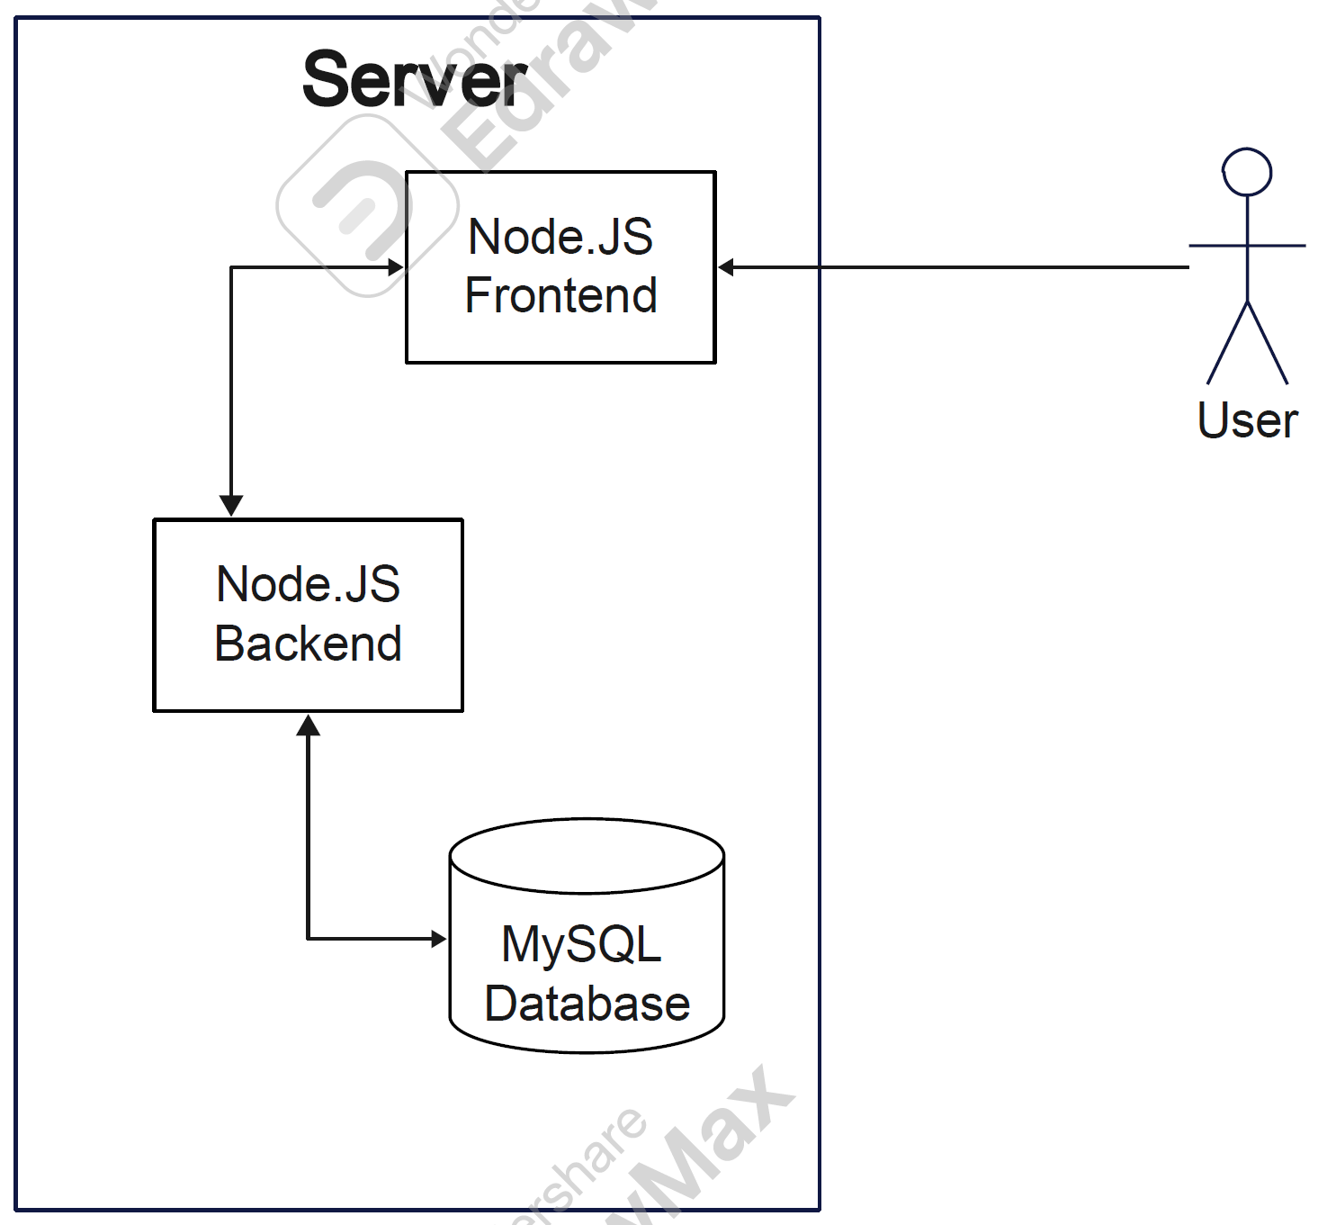
- User: User Table has all the user details which are collected when user email is registered/verified
A user belongs to one county (identified by county ID or name). County has multiple users
  - User ID (Primary Key) – INT
  - Password - VARCHAR (255)
  - Email Address - VARCHAR(55)
  - Phone Number - INT
  - Role (p1, p2, p3) - ENUM(P1,P2,P3)
  - County Name/ID - VARCHAR(255)/INT
  - Verified/Registered - BOOLEAN

- County: County Table has ID, Name, and lat long for mapping
  - County ID (Primary Key) - INT
  - County Name - VARCHAR(255)
  - Latitude, Longitude – DECIMAL

- Department: Department had ID and name and is linked to County ID, one county can have multiple departments
- Department ID (Primary Key) – INT
- Department Name (Sheriff/Security, Weather, Health, Fire) - VARCHAR/ENUM
- County ID (Foreign Key) – INT

- Metrics: Each metric has a type/value which indicates COVID-19 cases per 100k, covid deaths per 100k, wildfire levels, etc.

A department can report/store multiple metrics.
- Metric ID (Primary Key) – INT
- Department ID (Foreign Key) – INT
- County ID (Foreign Key) – INT
- Metric Type – VARCHAR
- Metric Value – DECIMAL
- Timestamp – DATETIME

- Alert: When a metric reaches an alert level, there is an entry in alert able (with a message), it’s triggered by a director or Admin level user
- Alert ID (Primary Key) – INT
- Metric ID (Foreign Key) – INT
- Alert Message – TEXT
- Triggered By (User ID, Foreign Key) – INT
- Timestamp - DATETIME

- User_Alerts: User to Alert mapping. Users can receive multiple alerts, and alerts can be sent to multiple users
- User ID (Foreign Key) – INT
- Alert ID (Foreign Key) – INT
Storage for Video and Audio files (should it be necessary) will happen on the server and the physical path will be saved in the database to be able to locate it again. To save space the data will be converted to a Base64 string and sent in a request body.

Searching and Filtering
Below is a list of filters on per table basis:
User Table:
- List users by role
- List all users from a given county
- Show all registered users (email verified)
Metrics Table:
- Search by Metric Type
- Search by Time Period: Show metrics from the last week, month, year, etc.
- Display metrics specific to a department
Other general filters:
- Show counties with more than x COVID-19 cases per 100k
- Show recent alerts (from last x days) - departments that have most metrics in the last x days
The filters/searches will be realized with well formulated SQL commands.

APIs:
User APIs:
- Add User
- POST request
- /api/user/add
- Parameters: email, phone_number, role, county_id, encrypted password (in body)
- Adds a new user to the User table

- Get Users by Role
- GET request
- /api/user/role/{role}
- Get users by role (p1, p2, p3)

- Get Users by County
- GET
- /api/user/county/{county_id}
- All users from a county. Metrics API

- Add Metric
- POST
- /api/metrics/add
- Parameters: metric_id, department, county, metric_type, metric_value, timestamp
- Description: Adds a new metric the Metric table.

- Get Metrics by Type
- GET
- /api/metrics/type/{metric_type}
- metrics based on their type

- Get Metrics by Time Period
- GET
- /api/metrics/timeframe?start={start_date}&end={end_date}
- metrics within a specified time frame

- Get Metrics by Department
- GET
- /api/metrics/department/{department_id}
- metrics specific to a department

Alert APIs:
- Get Recent Alerts
- GET
- /api/alerts/recent?days={x}
- alerts from the last x days

- Add Alert
- POST
- /api/alerts/add
- Parameters: metric_id, alert_message, triggered_by
- Adds a new alert to the Alert table
User Alerts APIs:
- Get User Alerts
- GET
- /api/user-alerts/user/{user_id}
- all alerts for a specific user
General APIs:
- Get Counties by COVID-19 Cases (repeat for other types)
- GET
- /api/counties/covid-cases?threshold={x}
- counties with more than x COVID-19 cases per 100k.

- Get Departments with most metrics
- GET
- /api/departments/top-metrics?days={x}
- departments that have reported the most metrics in the last x days

Algorithms:
Then only special algorithm potentially being used is the Dijkstra algorithm should a feature for route calculation be included

4. High Level UML Diagrams
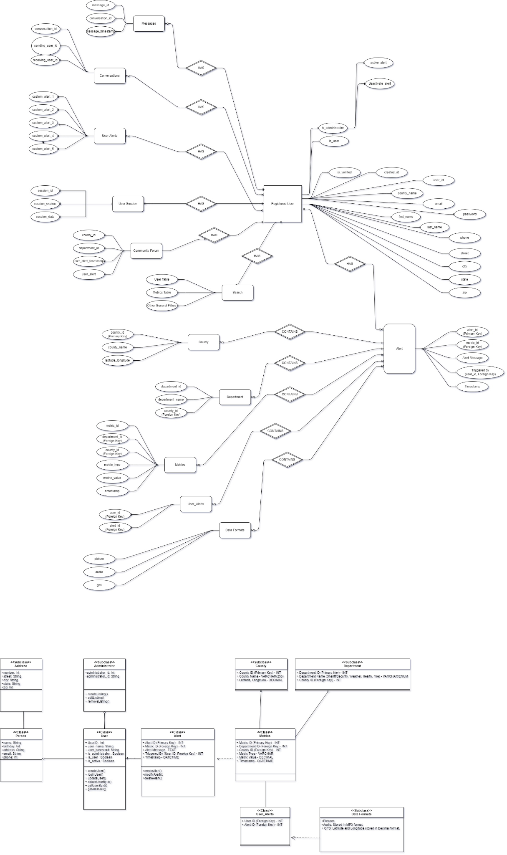
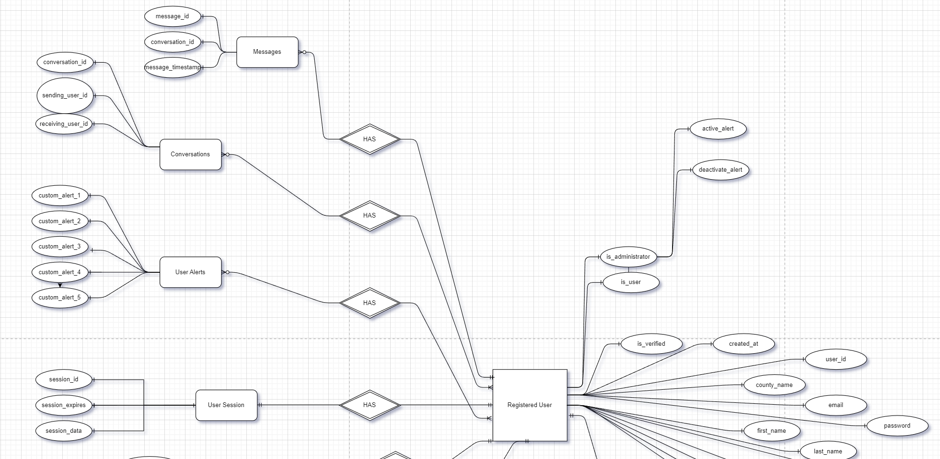

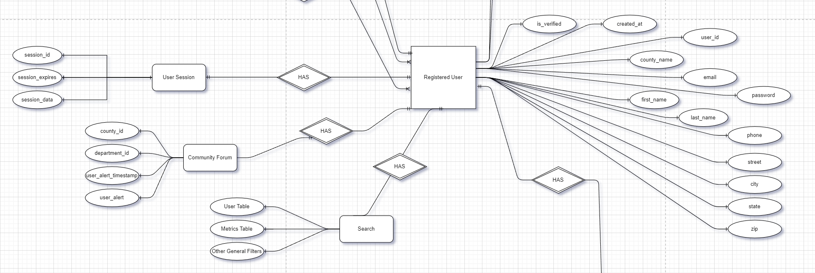

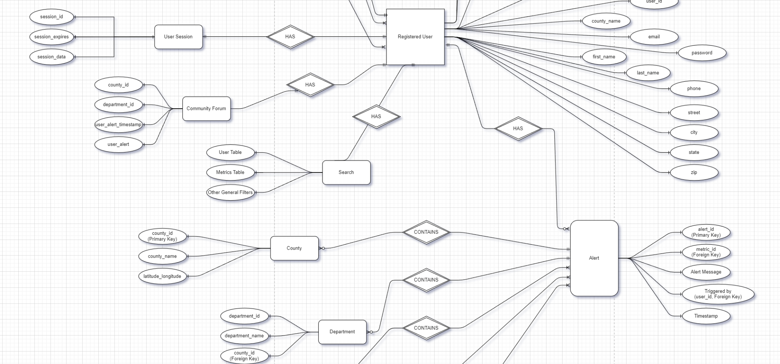

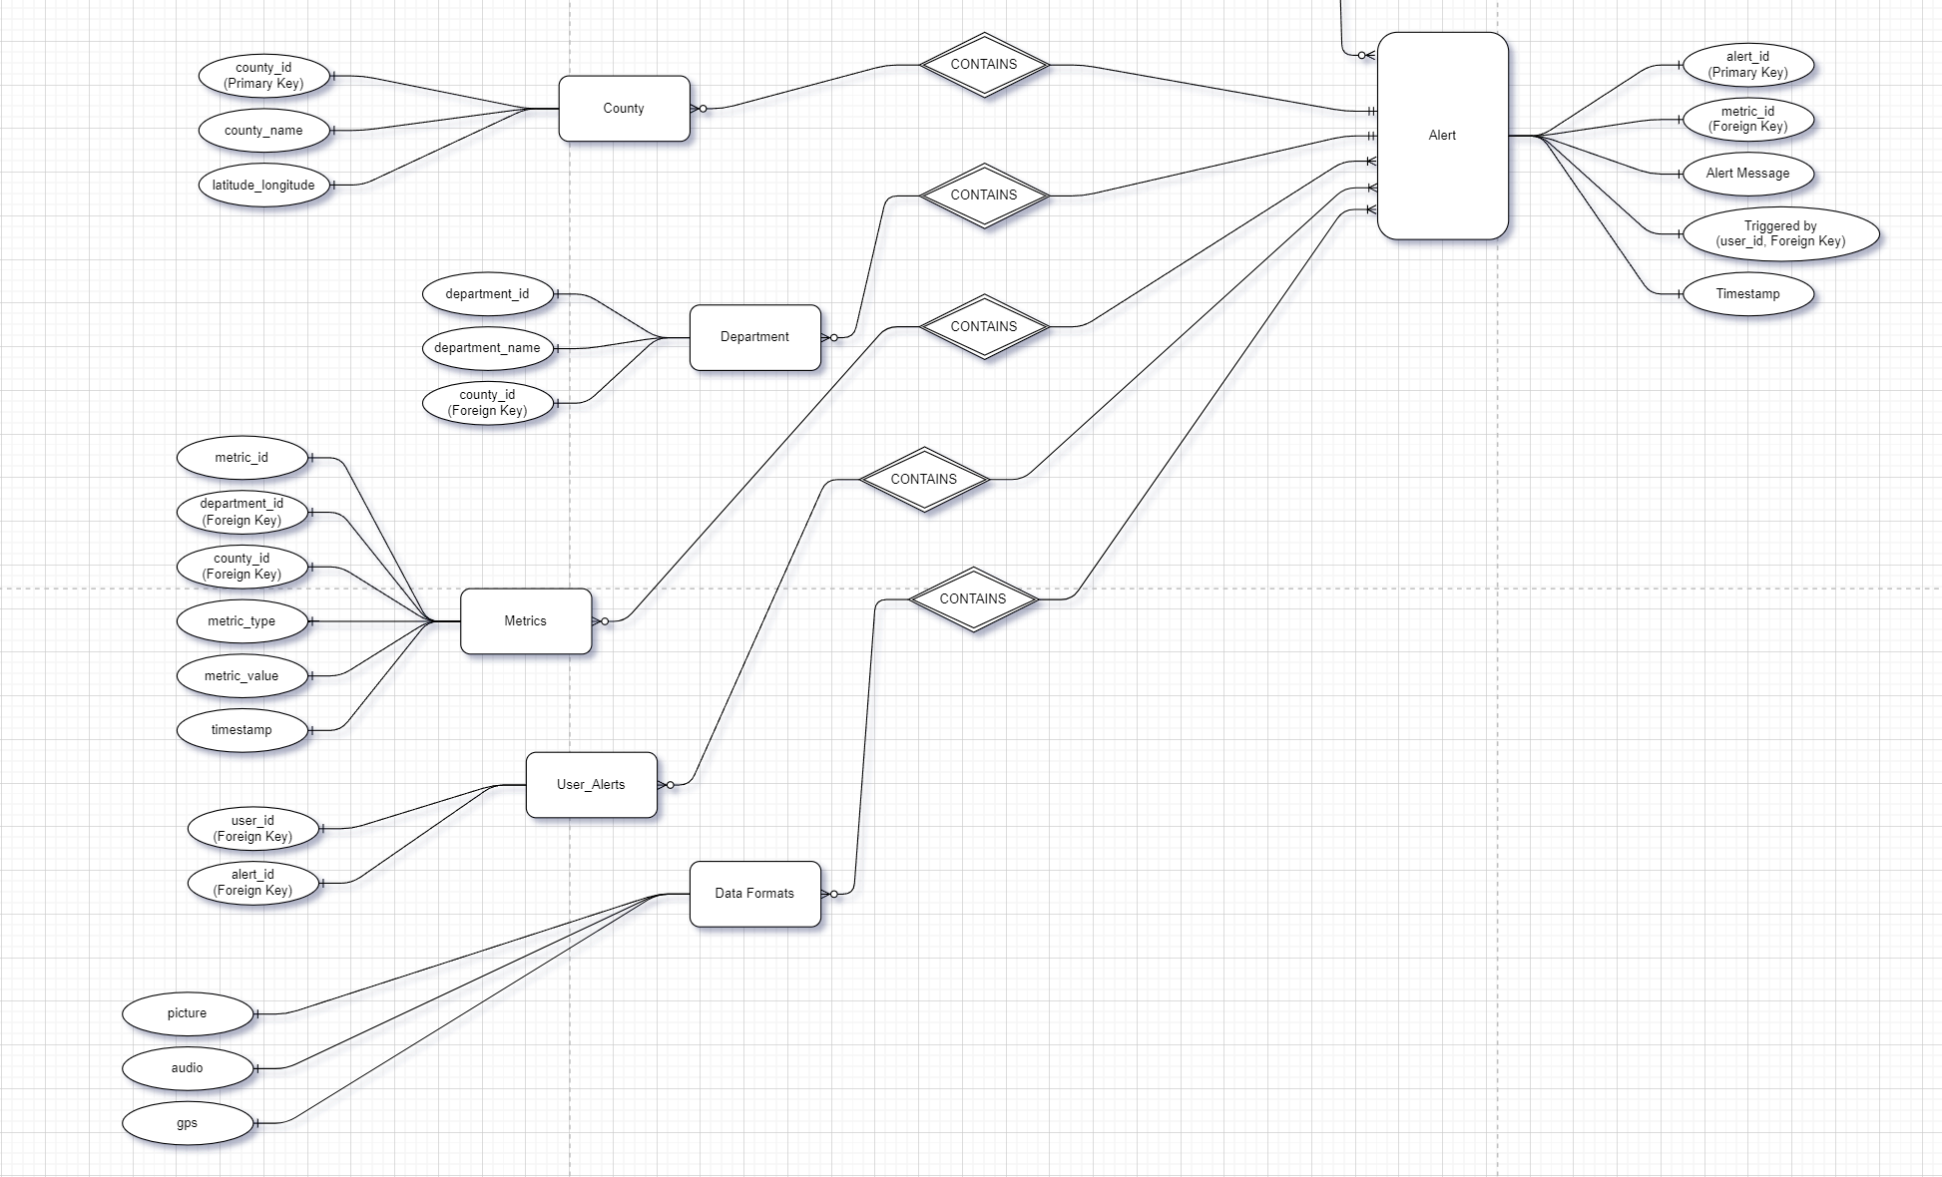
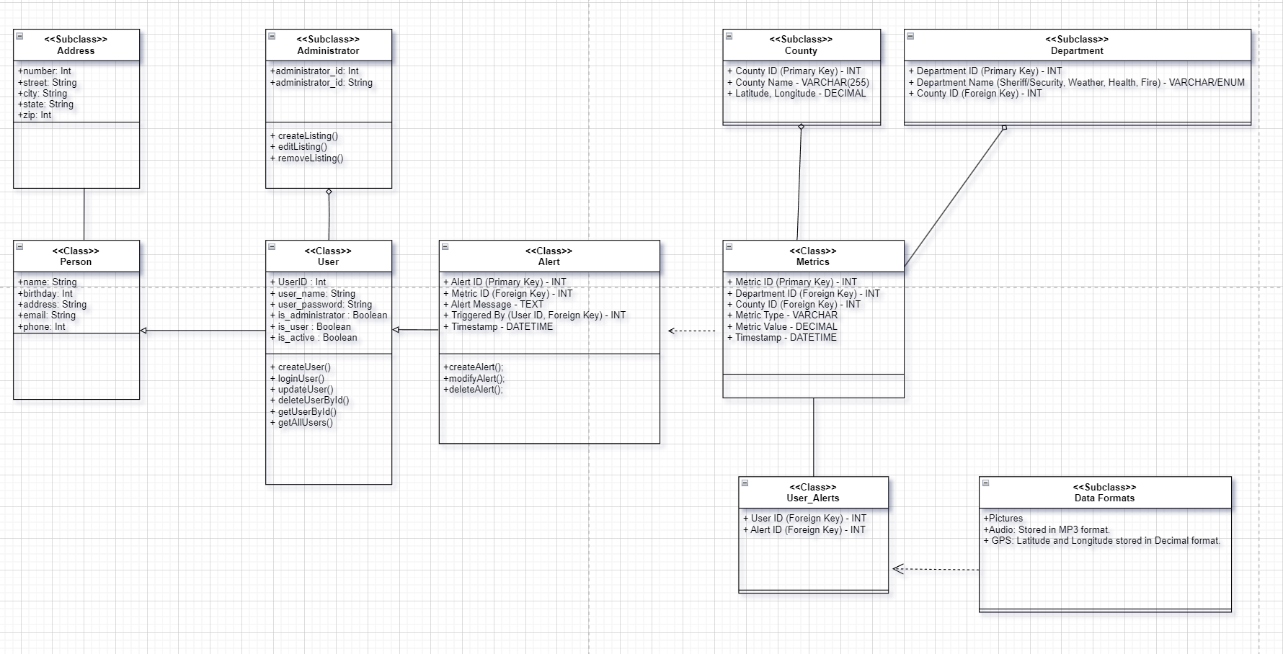
Architecture and Organization
- Registered User
  - Attributes
    - is_verified
    - created_at
    - user_id
    - county_name
    - email
    - password
    - first_name
    - last_name
    - phone
    - street
    - city
    - state
    - zip
    - is_user
    - Is_administrator
  - Relationship
    - search
    - community forum
    - user sessions
    - user alerts
    - conversations
    - messages
    - alert

- Search
  - Attributes
    - user table
    - metrics table
    - other general filters
  - Relationship
    - user
    - alert
    - metrics
    - county
    - department
    - user_alerts
    - data formats
- Community Forum
  - Attributes
    - County_id
    - Department_id
    - User_alert_timestamp
    - User_alert
  - Relationship
    - user
    - alert
    - metrics
    - county
    - department
    - user_alerts
    - data formats
- User Session
  - Attributes
    - session_id
    - session_expries
    - session_data
  - Relationship
    - user
- User Alerts
  - Attributes
    - custom_alert_1
    - custom_alert_2
    - custom_alert_3
    - custom_alert_4
    - custom_alert_5
  - Relationship
    - user
    - alert
- Conversations
  - Attributes
    - converstion_id
    - sending_user_id
    - receiving_user_id
  - Relationships
    - user
    - messages
- Messages
  - Attributes
    - message_id
    - conversation_id
    - message_timestamp
  - Relationship
    - converstions
- Alert
  - Attributes
    - alert_id (primary key)
    - metric_id (foreign key)
    - alert message
    - triggered by (user_id, foreign key)
    - Timestamp
  - Relationships
    - County
    - Department
    - Metrics
    - User_Alerts
    - Data Formats
- County
  - Attributes
    - county_id (primary key)
    - county_name
    - latitude_longitude
  - Relationships
    - alert
    - user
- Department
  - Attributes
    - department_id
    - department_name
    - county_id (foreign key)
  - Relationships
    - alert
    - user
- Metrics
  - Attributes
    - metric_id (primary key)
    - department_id (foreign key)
    - metric_type
    - metric_value
    - timestamp
  - Relationships
    - alert
    - user
- User_alerts
  - Attributes
    - user_id (foreign key)
    - alert_id (foreign key
  - Relationships
    - alert
    - user
- Data Formats
  - Attributes
    - picture
    - audio
    - gps
  - Relationships
    - alert
    - user

5. Risks
There are two key risks we identified:
- schedule
- skill
Many team members are very busy and have long commutes which prevents them from working as much as necessary on the assignments. This in turn leads to a risk of skill since they also don’t have the time to learn the required skills (should they not already have it), a possible solution is to move the out of class meeting online and forcing everyone to actually come to class. The use of Trello is also a key solution I identified to help everyone keep track of things.

6. Project management
Starting with this milestone we’re starting to work with a modified scrum methodology that works in sprints with the duration of the next milestone. After each milestone we’ll discuss things in a retrospective and then act accordingly. To visualize the sprint progress we’ll use Trello, this will also help with keeping track of everyone’s work and ensures that things that are not on track are noticed as soon as possible. Every task will be designated as frontend, backend, or database, from there any team member of this sub team can take the task and start working on it. This works a little differently than for Milestone 2, where very specific work was assigned to each team member and then closely monitored by the team lead following the experience Milestone 1.

Additionally, frontend and backend teams are encouraged to work independently and discuss things with each other without having to involve the team lead if not for important points of discussion.

This should help to ensure that everything is being completed in time and ready to being presented when necessary.

